Clockwork Kode Redeemer

# Update

## Web

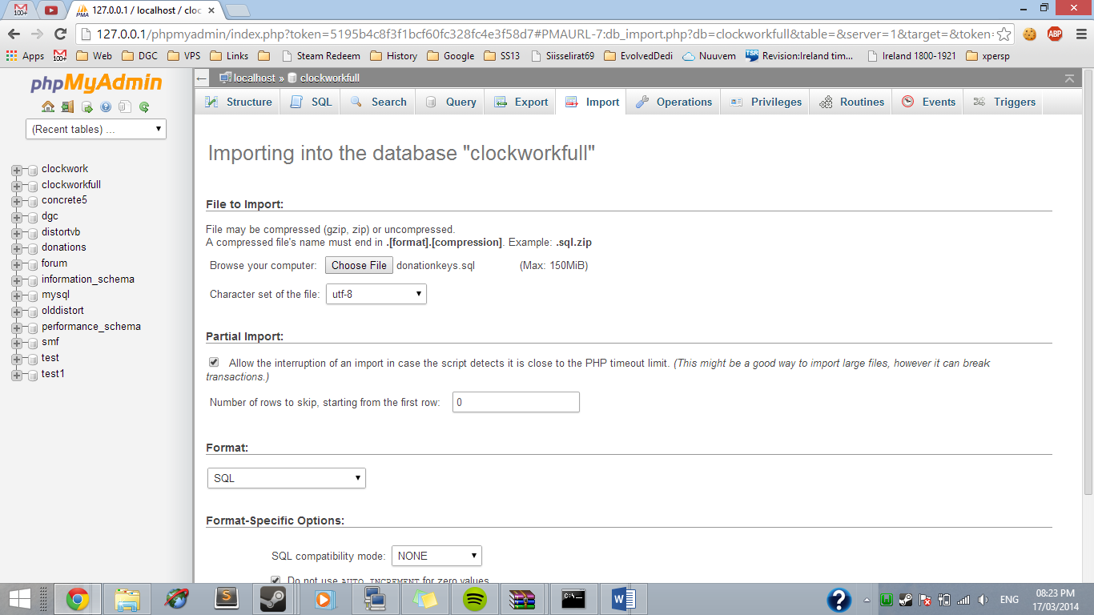The new version (28/3/14) includes a newer mysql table. You will lose any current data in the tables, so please export them first. You can add older keys to the database later.

# Installation

## Web

Extract the ‘web’ files and upload them to a website.

Upload both .sql file to your clockwork database (or another)



Edit config.php

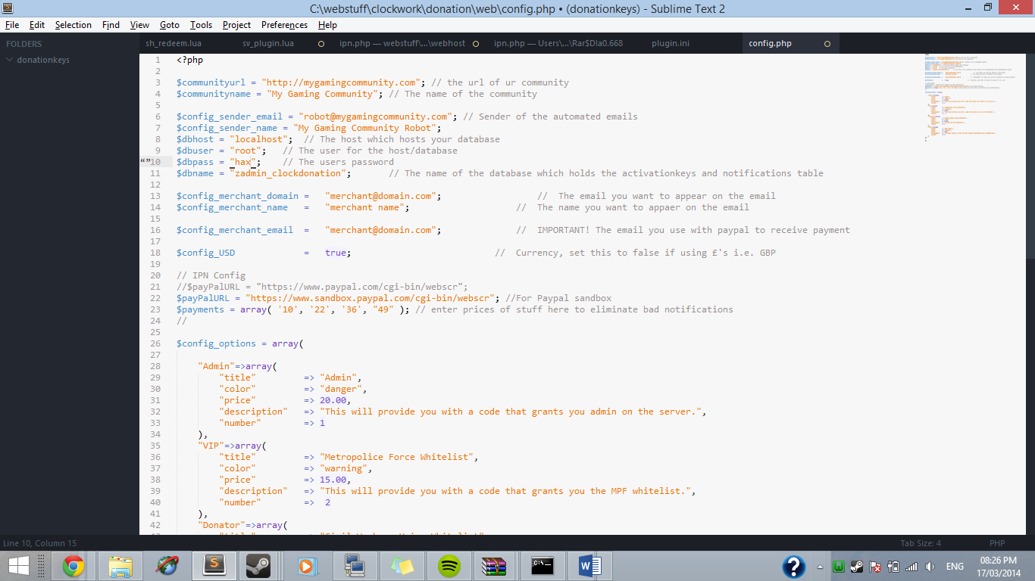

## Packages

These are pretty simple, for each ‘package’ you follow this format

"Admin"=>array(

"title" => "Admin",

"color" => "danger",

"price" => 20.00,

"description" => "This will provide you with a code that grants you admin on the server.",

"number" => 1

),

The colors are seen here, use the name of the button.

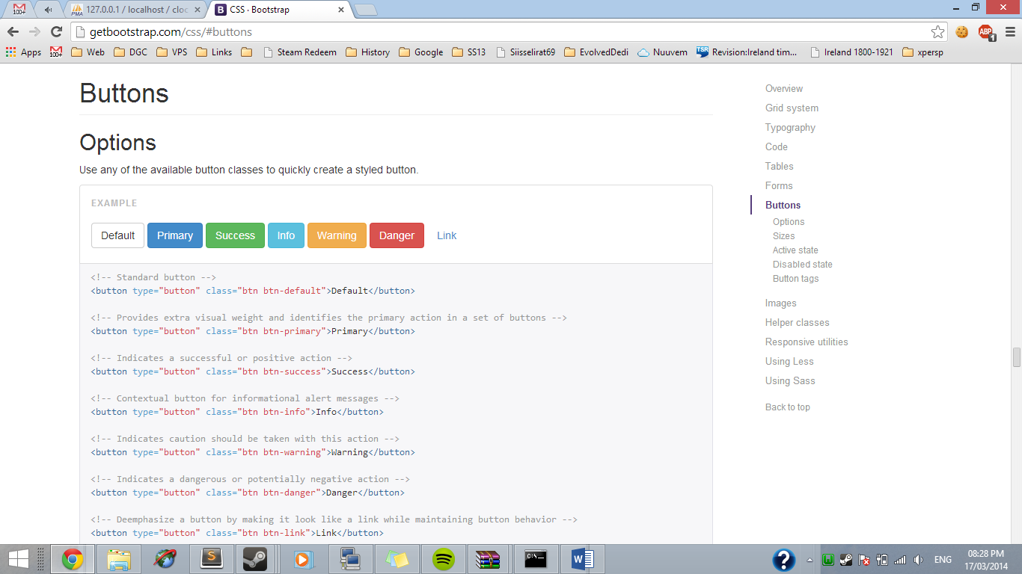

<http://getbootstrap.com/css/#buttons>

The “number” will be needed later, just make sure they are unique.

The $paypalurl should stay at <https://www.paypal.com/cgi-bin/webscr>

## Paypal setup

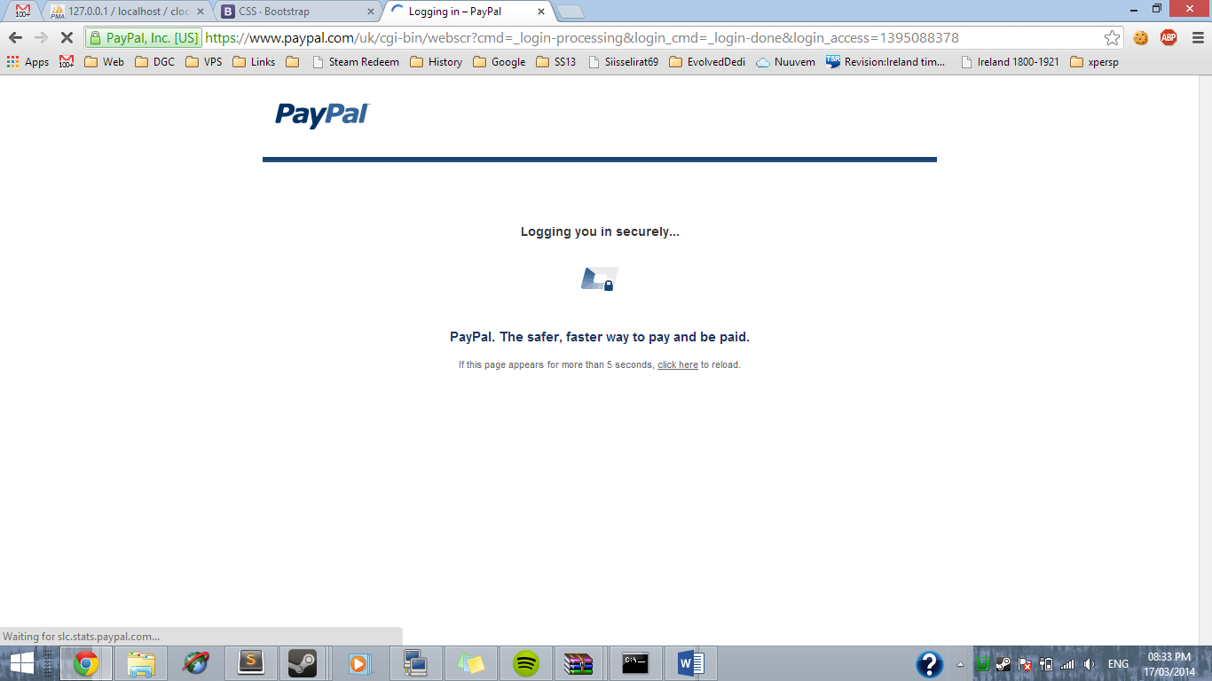Login to your PayPal

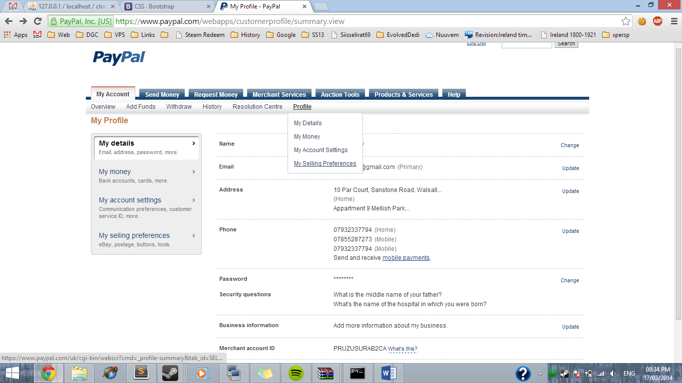Then go to My Selling Preferences

Click Instant Payment Notifications

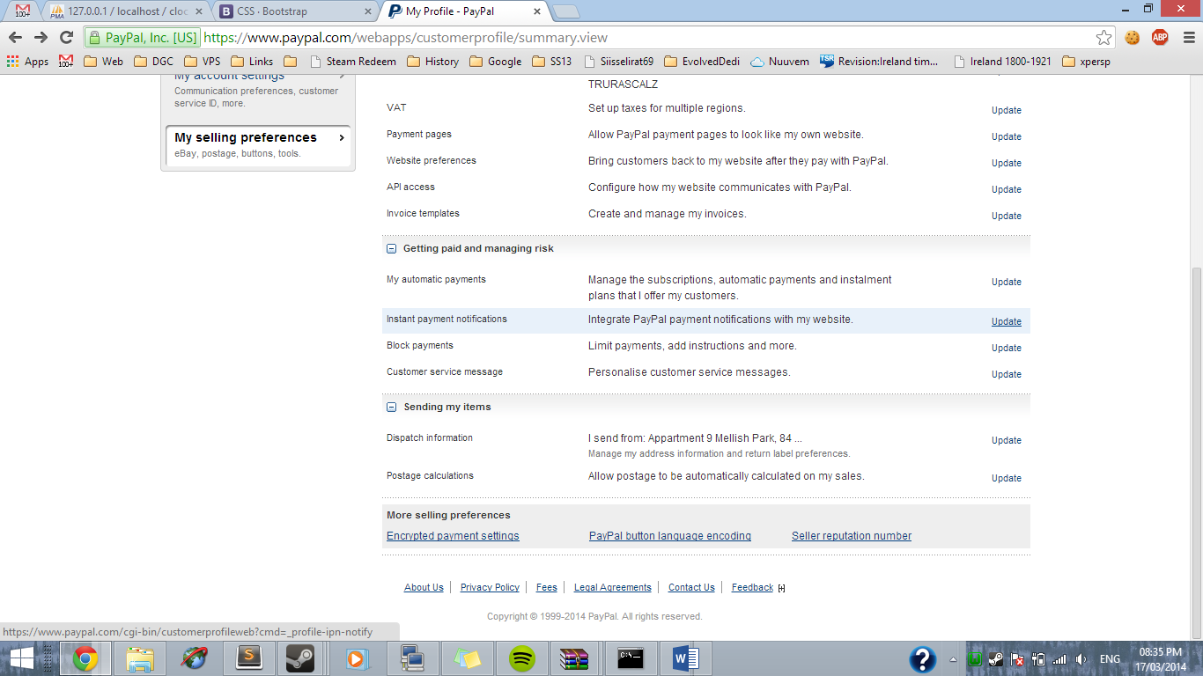

Then “Choose”

In this part you enter the URL where you placed your website files, you should see a folder called ipn, inside that should be ipn.php make sure that is in the URL you enter.

http://mygamingcommunity.com/donate/**ipn/ipn.php**

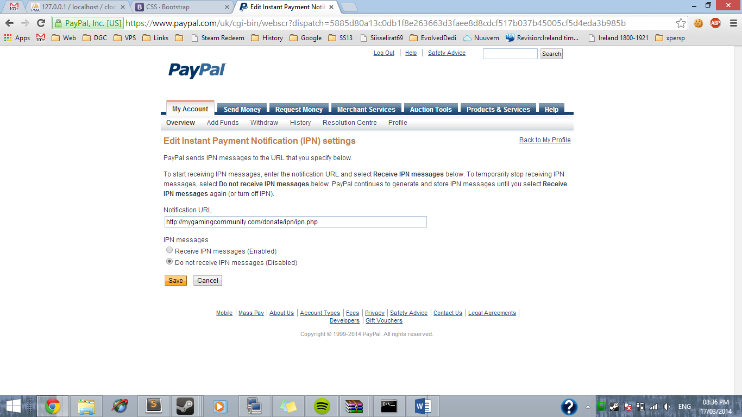

Then Enable & Save.

# Game server files

**IMPORTANT STEP**

**You need to place the gmsv_mysqloo_win32.dll into /garrysmod/lua/bin**

Then just upload the plugin files to the clockwork directory.

Open sv_plugin.lua

The first thing you will see is packages. I have provided 4 default packages, but you see the number in the [] ? That is the number from the web file step I told you to remember. Fill it in likewise. I have given you some sample functions that can be done, like whitelists and tokens. If you have no idea how to change them you should ask someone.

**For some reason the flag code I used didn’t work. So I don’t know how to give flags yet**

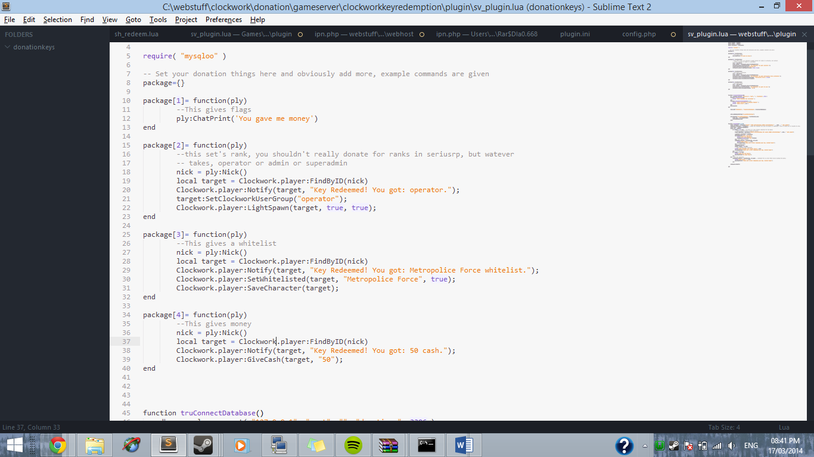

Once you have done that on line 46, you see

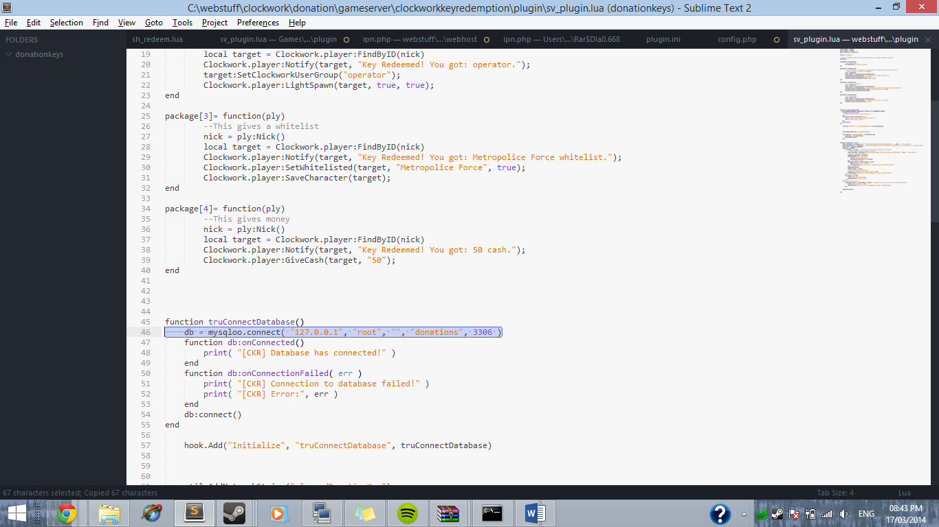

Fill that in with your database information. The format is: **host,username,password,database,port**

# Done!

That was simple right! (lol). Since we did all that lets check some stuff.

Is the MySQL info correct in both the website and gameserver?

Do the package numbers match in both parts?

Did you set your IPN url?

Help will be available in the thread. To use keys, people have to type /redeem in game.